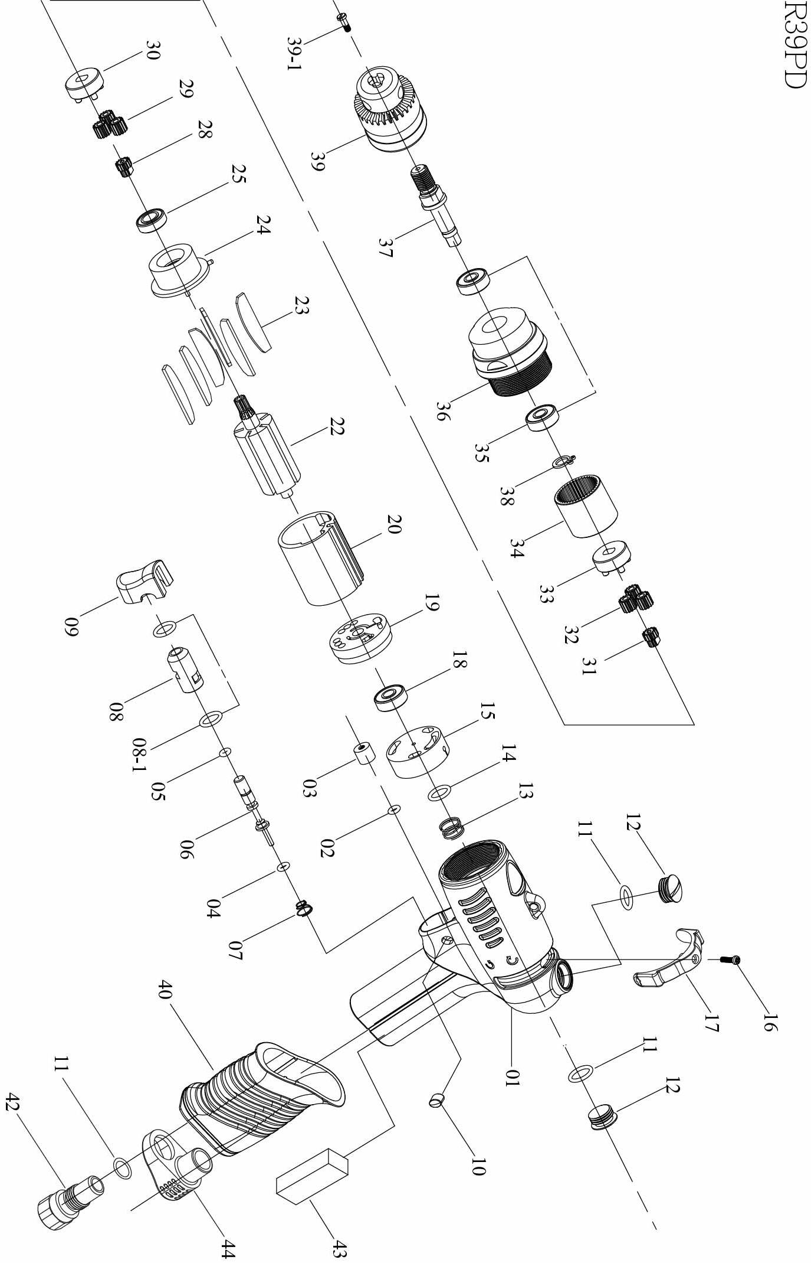

No. | Part No. | Part Name | Q’ty | No. | Part No. | Part Name | Q’ty
1 | 5L2108 | Pistol Housing (Red) | 1 | 22 | 1S3035 | 7T Rotor | 1
2 | 7Q2008 | O Ring | 1 | 23 | 1P3081 | Blade | 6
3 | 2C2003-A | Blank Cap | 1 | 24 | 1P3062 | Front Plate | 1
4 | 7Q2007 | O Ring | 1 | 25 | 7S2002 | Ball Bearing | 1
5 | 7Q6112 | Valve O-Ring | 1 | 28 | 1P2275 | 18T Main Gear | 1
6 | 6S2023 | Valve Pin | 1 | 29 | 1P2112 | 12T Plant Gear | 4
7 | 6N2106 | Cone Spring | 1 | 30 | 1P2291 | Third Gear Cage | 1
8 | 6S2024 | Valve Bushing | 1 | 31 | 1P5101 | 14T Main Gear | 1
8-1 | 7Q2009 | O-Ring | 2 | 32 | 1P2131 | 14T Plant Gear | 4
9 | 5L2701 | Button (Black) | 1 | 33 | 1P2294 | Fourth Gear Cage | 1
10 | 5L2116 | Cap (Black) | 2 | 34 | 1S2069 | Internal Gear | 1
11 | 2Q5001 | O Ring | 3 | 35 | 7S2010 | Ball Bearing | 2
12 | 2S2011 | Screw Cap | 2 | 36 | 5A5352 | Gear Housing | 1
13 | 6N2108 | Spring | 1 | 37 | 3S5044 | Anvil | 1
14 | 7Q2017 | Valve O-Ring | 1 | 38 | 6N2081 | C Ring | 1
15 | 6S2204 | Valve | 1 | 39 | 7S3109 | Drill Chuck | 1
16 | 7S2107 | Set Screw And Washer | 1 | 39-1 | 7S2117 | Left Screw | 1
17 | 2L3012 | Switch | 1 | 40 | 5L3207 | Pistol Cover | 1
18 | 7S2001 | Ball Bearing | 1 | 42 | 2S2008 | Air Inlet Bushing [PS] | 1
19 | 1S3001-A | End Plate | 1 | 43 | 2P3040 | Silencer | 1
20 | 1P3005 | Cylinder | 1 | 44 | 2P3041 | Silencer For Pistol | 1

